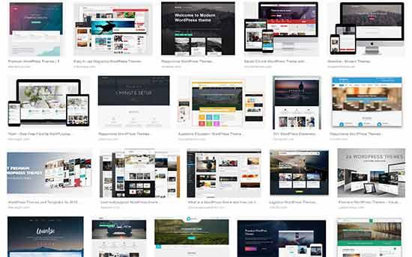

WordPress themes control the look of your website. Themes are pre-made templates that you can install and customize for your site.

There are thousands of free and premium themes available for WordPress. You can download free themes from the [WordPress Themes directory](http://wordpress.org/themes/).

For premium themes, you can go to [commercial theme shops](https://www.wpbeginner.com/showcase/best-commercial-wordpress-theme-shops/) like [StudioPress](https://www.wpbeginner.com/refer/studiopress/), [Elegant Themes](https://www.wpbeginner.com/refer/elegantthemes/), [Themify](https://www.wpbeginner.com/refer/themify/), etc.

A perfect theme should be a balance of beautiful design and powerful features. Too many features are not always a sign of a good Theme. Check out our guide on choosing the [perfect WordPress theme](https://www.wpbeginner.com/wp-themes/selecting-the-perfect-theme-for-wordpress/) for your website.

If you want to look at specific WordPress themes, then see our WordPress theme showcases:

* [Best and most popular WordPress themes (all-time)](https://www.wpbeginner.com/showcase/best-wordpress-themes/)
* [Best free WordPress blog themes](https://www.wpbeginner.com/showcase/best-free-wordpress-blog-themes/)
* [Best free WordPress business themes](https://www.wpbeginner.com/showcase/21-best-free-wordpress-business-themes/)
* [Best WordPress magazine style themes](https://www.wpbeginner.com/showcase/best-wordpress-magazine-themes/)
* [Best WordPress themes for photographers](https://www.wpbeginner.com/showcase/best-wordpress-themes-for-photographers/)

Once you have found a theme, follow the instructions in our guide on how to [install a WordPress theme](https://www.wpbeginner.com/beginners-guide/how-to-install-a-wordpress-theme/) to properly install it.

After that, refer back to our WordPress videos from Tuesday to see how you can change the background, add header images, add menus, and more in your WordPress theme.